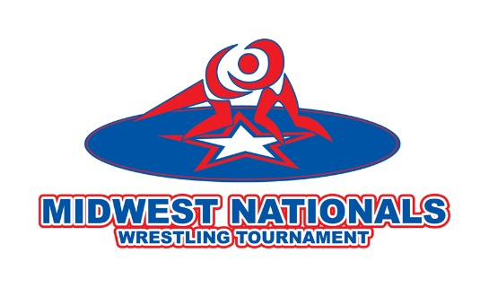

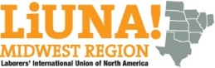

2019 OFFICIAL ENTRY FORM

July 13th, 2019 • Illinois Wesleyan University Shirk Center
Weigh-Ins July 12th, 5pm-8pm

The Midwest Nationals presented by the Midwest Laborers is organized by the
Bloomington-Normal Area Sports Commission, Illinois Wrestling Coaches and Officials Association, and Illinois Coaches Association.

Name _______ Sex ______
Last First Middle

Home Address ___________________________________________________________ ______________ Phone _________________________

City ____________________________________________________________________ State ____________ Zip Code ____________________

Emergency Contact __________________________________________ ___________ Emergency Phone _________________________

Birthday ______________________________________ E-Mail __________________________________________________________________
Month Day Year

Name of Parents _________________________________________________________________________________________________________

How Did You Hear About the Midwest Nationals? ___________________________________________________________________

Hometown Newspaper _________________________________________________________________________________________________
Name City / State Fax or E-Mail Address

Team Name (spell full name) __________________________________________________________________________________________

Folk Style rules apply unless otherwise noted.
AAU and USA cards are NOT required to participate.

CHECK YOUR AGE DIVISION BELOW (This is the grade that you were in the past year)

MEN SCHOOL GRADE ENTRY FEE WOMEN SCHOOL GRADE ENTRY FEE
□ 1st & 2nd $ 50.00 □ 1st & 2nd $ 50.00
□ 3rd & 4th $ 50.00 □ 3rd - 5th $ 50.00
□ 5th & 6th $ 50.00 □ 6th - 8th $ 50.00
□ 7th & 8th $ 50.00 □ 9th & 10th $ 50.00
□ 9th & 10th $ 50.00 □ 11th & 12th $ 50.00
□ 11th & 12th $ 50.00 □ College/Open $ 50.00 (FREE STYLE)
□ College/Open $ 50.00
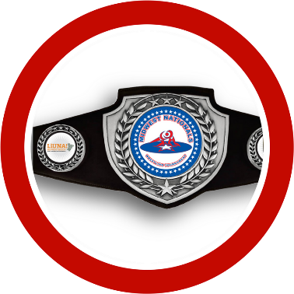
Registration is also available online at www.trackwrestling.com

Return all materials to:
Midwest Nationals, 3201 CIRA Dr., Suite 201, Bloomington, IL 61704, USA

Authorization and Release

Release must be signed by parent or guardian if applicant is under age 18 as of the date of this release.

Wrestler’s Name: ____ Birth Date: _

I hereby certify that facts in this entry form are true and correct. I certify that the birth date is correct. I understand that by participating in the Midwest Nationals, the name, photograph or other image, and other information (including but not limited to age and hometown) relating to the participant may be used for publicity purposes. Publicity purposes may be in the form of brochures, postings on the tournament web site, videos, displays, radio programs, newspaper releases or articles, or other forms of media.

The undersigned Applicant, for his or her heirs, assigns and legal representatives, releases, discharges and holds harmless the Midwest Nationals Committee, the Bloomington-Normal Sports Commission, the Bloomington-Normal Area Convention and Visitors Bureau, all tournament and title sponsors and their affiliates, their directors, officers, members, employees, staff, volunteers, agents and representatives from any and all liability for any events or consequences whatsoever and in any manner arising out of or related to Applicant’s entry and/or participation in this tournament, including but not limited to personal injuries sustained by Applicant.

In the event of a medical emergency occurring during the tournament, the undersigned hereby authorizes all necessary measures in the medical treatment of Applicant.

Signed Relationship to Applicant _
Signature of Parent or Guardian

Signed Date ____ _ _
Signature of Applicant

Midwest Nationals General Information and Age/Eligibility Acceptance

(Please read carefully all information concerning the Midwest Nationals General Information and Age/Eligibility. Make sure this section is signed by both the applicant and parent or guardian.)

The signatures below verify that both applicant and parent or guardian have read the Midwest Nationals General Information and Age-Eligibility.

X___________________________________________________________ X_______________________________________________________________
(Applicant) (Parent or Guardian)

Payment Method (check one): Check # _________ (payable to: Midwest Nationals)

Money Order __________ (payable to: Midwest Nationals)

CHECKLIST for APPLICANT

(1) Completed Entry Form (Birth date verification may be requested)
(2) Completed Authorization and Release Form signed by parent or guardian (above)
(3) Midwest Nationals General Information and Age/Eligibility Acceptance signed by applicant and parent or guardian (above)
(4) Correct Entry Fee and payment method box completed. (If more than one applicant, fees may be combined for payment)

**BLANK ENTRY FORMS MAY BE DUPLICATED**

TOURNAMENT HEADQUARTERS ♦ 3201 CIRA Dr., Suite 201, Bloomington, IL 61704 ♦ (800) 433-8226
